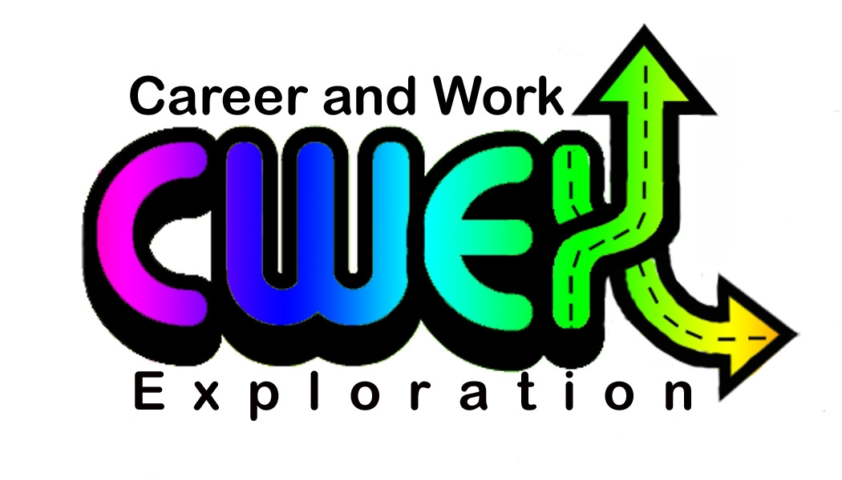
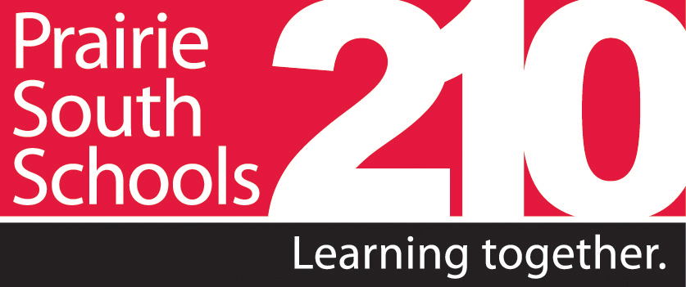
Prairie South School Division No. 210
Career and Work Exploration Program
SUGGESTED INTERVIEW QUESTIONS

Students enrolled in the Career and Work Exploration Program are required to follow an interview process. Employers are asked to conduct an interview with students similar to that of a potential employee. We have provided both traditional interview questions, along with some behavioural interview questions that many employers are now asking prospective employees. Regardless of which questions you ask, we recommend that you ask around five to seven questions. Please note that because this work placement may be the first job that some students have had, they may need to provide examples from school or elsewhere to answer these questions, rather than from previous jobs.

- Give me an example of a problem you have faced on the job or with some kind of work you have done in the past and how you solved it.

- What do you do when people disagree with your ideas?

- Describe a time when you were not satisfied with work you’ve done, either on the job or in school and what you did about it.

- Explain a time when you went above and beyond the call of duty to get a job done.

- Tell me about a situation when it was important for you pay attention to details. How did you handle it?
- Tell me about your qualities and talents that would help you in this work placement.
- What do you want to accomplish/learn in this work placement?
- What are some areas you see yourself wanting to improve?
- What have been your most rewarding experiences in school?
- Tell me about a time you worked on a project as a team member and what you contributed.
- Tell me about a goal you had set and how you went about reaching it.
- If you have a difficult decision to make, how do you go about making it?
- What are your hobbies and outside interests?
- What do you see yourself doing in the next three to five years?
- Do you have any questions?

