
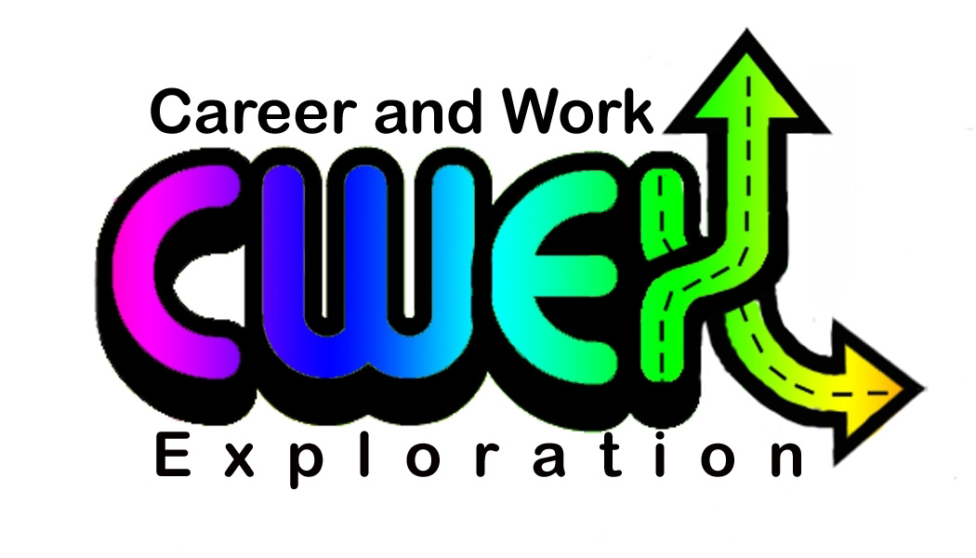
IMPORTANT INFORMATION
FOR EMPLOYERS

- Green Form: The student must present a (green) Work Placement Agreement/Schedule B form that must be signed by the parent, student, teacher, and employer BEFORE the student starts work. Otherwise, there will not be any workers’ compensation if there is an injury and claim attempted. This green form provides the workers’ compensation coverage for you as the employer, the school division, and the student. Any claims will be handled by the consultant, with no changes to the workers’ compensation premiums of the employer. A memo from the school division explaining the workers’ compensation and insurance issues is included.

- Interview and Evaluation: The student(s) working with you will call you to confirm the date and time of their interview. Complete the interview evaluation on the first day. Discuss this with the student.

- Employer Health and Safety Orientation Checklist: The student will need to complete this form to gain a good understanding of the safety elements that are important to your specific workplace. This must also be done on the first day.

- New Employees: We want students treated like first time employees, with the understanding that they may have little to no background in the particular field in which they are going to be working. However, you don’t have to deal with the potentially negative aspects—disciplinary action, firing, etc., unless you wish to do so.

- Communication: The Career and Work Exploration (CWEX) Teacher will make either three or four visits to your place of business during the student’s work placement, depending on the number of hours of the course. Open communication between the CWEX Teacher and you as the employer is crucial to ensuring a positive experience for everyone involved in the program. A business card with contact information is provided on the left side of the folder. Please feel free to contact the CWEX Teacher with any concerns.

- Potential Problems: If the student is late or does not show up for work and does not call you, please call the CWEX Teacher as soon as possible. If the student is not working as well as you think he or she should or has anything other than a positive, hard-working attitude, please call the teacher. We desire to have problems solved as quickly as possible.
- Student Driving Form: We discourage the driving of an employer-owned vehicle, as it increases the liability issues for the employer, the school division and the student. If you require the student to drive an employer-owned vehicle as part of the job, there is an additional form that must be signed by all parties involved—student, parent, teacher, and employer. (This form is not included in this folder.)

- Student Calendar: The calendar is included as an indication of the days the student will be at work. In some circumstances, you and the student may wish to arrange additional hours of work outside of these times, and you are free to do so. If the student is working during a holiday or on weekends, it is important for the teacher to know so that he or she can plan the monitoring visits.

- Student Time Sheets: Students are responsible for keeping track of their hours. Forms are included. However, there is a spot on that form that you need to sign or initial to verify these hours.

- Evaluation of Student Performance: Two evaluation checklists are included for you to complete part way throughout the semester and near the end of the semester. Students are responsible for reminding you when evaluations are due.

- Evaluation of Program: In an effort to ensure that the CWEX program is as successful as possible for everyone involved, we ask employers to complete an evaluation of the program. Please complete this and return to the CWEX Teacher or send it with the student on one of the last days of work.

- Emergency Contact Information: Emergency telephone numbers are located on the folder.

DOCUMENTS CONTAINED IN EMPLOYER FOLDER

      - School Division Insurance Memo
      - Student Calendar (with due dates for the documents)
      - Suggested Interview Questions
      - Interview Checklist—Employer Assessment
      - Employer Health and Safety Orientation Checklist
      - Student Time Sheet (2 copies)
      - Employer’s Evaluation of Student Performance
(2 copies: one for mid-term evaluation and one for final evaluation)
      - Employer’s Evaluation of Program

